|  |  |
| --- | --- |
| Enrollment ID | Name |
| Student1414755 | Faizan Amir |
| Student1416781 | AYAAN |



Group Members:

EPROJECT

Developer Guide

*Semester: DISM*

Supervisor: Sir Usama Riaz

Title: Lab Automation

**Certificate of Completion**

This is to certify that the eProject documentation for the Lab Automation System has been successfully completed. The comprehensive documentation outlines the existing scenario, proposed solution, and functional requirements for the development of an application to streamline the testing process for electrical products at SRS Electrical Appliances.

Details of Completion:

- **\*\*Introduction:\*\*** The document provides a clear introduction to SRS Electrical Appliances and the need for an automation system in their testing process.

- **\*\*Existing Scenario:\*\*** A thorough analysis of the current testing process is presented, highlighting the manual and paper-based nature of record-keeping, the challenges faced, and the potential for errors.

- **\*\*Proposed Scenario:\*\*** The proposed solution is well-detailed, emphasizing the development of a modular and sub-modular application to manage testing records efficiently. The inclusion of unique product and testing IDs, advanced search options, and detailed remarks ensures a comprehensive solution.

- **\*\*Non-Financial Requirements:\*\*** The document addresses non-financial aspects, such as the need for a separate database, unique product and testing IDs, advanced search functionality, modular design, and capturing detailed remarks and testing status.

- **\*\*Financial Requirements:\*\*** The financial implications are outlined, emphasizing the importance of successful testing for product approval and subsequent market release.

- **\*\*Functional Requirements:\*\*** The functional requirements section specifies the details to be captured based on testing and product types, the importance of testing status, and the inclusion of an advanced search option for easy retrieval of information.

**Conclusion:**

The completion of this eProject documentation signifies a thorough understanding of the Lab Automation System requirements at SRS Electrical Appliances. The proposed solution is robust and addresses both non-financial and financial aspects, providing a clear roadmap for the development of an efficient testing management application.

**\*Date of Completion: 11-11-2023**

**\*Project Team: Ayaan, Faizan Amir**

**\*Project Name: Lab-automation**

*Authorized Signature:* _______________________

**Acknowledgements**

We extend our heartfelt gratitude to the team at SRS Electrical Appliances for entrusting us with the Lab Automation System project. Special thanks to the dedicated individuals involved in providing valuable insights, requirements, and feedback throughout the documentation process.

This accomplishment would not have been possible without the collaborative efforts of our project team. Each member's commitment and hard work have contributed significantly to the clarity and completeness of this Eproject documentation.

We appreciate the support and guidance received from Sir Usama Riaz for steering us in the right direction. Their expertise and leadership have been instrumental in shaping the proposed solution and addressing the unique challenges presented by SRS Electrical Appliances.

Thank you to everyone involved for their contributions and commitment to the success of this project.

*Gratefully,*

**Problem Statement**

SRS Electrical Appliances faces challenges in the current manual testing and record-keeping process for their electrical products. The existing system involves maintaining paper records of product testing, leading to inefficiencies, potential misplacements, and time-consuming processes. The lack of automation results in difficulties in tracking product testing details, and there is a need for a streamlined approach to manage testing records, ensuring accuracy and accessibility. To address these issues, an automated system is required to handle the testing records, generate unique identifiers, and facilitate efficient tracking of product testing outcomes

**Introduction**

SRS Electrical Appliances specializes in manufacturing electrical products such as switch gears, fuses, capacitors, resistors, etc. These products undergo rigorous testing in-house, and upon successful testing, they are sent to the Central Power Research Institute (CPRI) for further approval. If the initial testing fails, the products are returned for re-manufacturing and retesting before resubmission to CPRI. The aim is to ensure compliance with industry standards and regulations before releasing the products into the market.

**Requirement Specification**

**Proposed Scenario:**

* Develop a modular and sub-modular application for efficient testing record management.
* Implement a unique 10-digit product ID and a 12-digit testing ID, automatically generated.
* Include advanced search options for quick and easy data retrieval.
* Capture detailed remarks, testing status, and tester information for each product.

Non-Financial Requirements:

* Establish a separate database to store product and testing details.
* Ensure the uniqueness of the 10-digit product ID and 12-digit testing ID.
* Design the application in a modular format based on product and testing types.
* Capture comprehensive remarks, testing status, and tester information.

Financial Requirements:

* Emphasize the importance of successful testing for product approval and market release.

Functional Requirements:

* Capture details based on testing and product types.
* Include testing status and detailed remarks.
* Implement an advanced search option for easy information retrieval.

Conclusion:

The requirement specification outlines the essential elements for the Lab Automation System, ensuring a comprehensive and effective solution for SRS Electrical Appliances.

** Objectives of the Project**

1. Automation Implementation

- Introduce an automated Lab Automation System to replace the manual, paper-based testing records at SRS Electrical Appliances.

2. Efficient Testing Process

- Streamline the testing process to reduce time consumption, minimize errors, and improve overall efficiency in maintaining testing records.

3. Record-Keeping Optimization

- Develop a modular and sub-modular application to efficiently manage and organize testing records based on product and testing types.

4. Unique Product and Testing IDs

- Implement a unique 10-digit product ID and a 12-digit testing ID for each product, ensuring distinct identification and easy tracking.

5. Advanced Search Functionality

- Include advanced search options to facilitate quick and easy retrieval of testing details, improving accessibility for the testing department.

6. Comprehensive Data Capture

- Capture detailed remarks for each testing instance, including criteria, testing outputs, and any additional remarks, enhancing the depth of information stored.

7. Testing Status Tracking

- Integrate a feature to track the status of each testing process, providing real-time information on the progress and outcomes.

8. Tester Information Capture

- Prompt for the entry of tester names upon record submission, ensuring accountability and traceability for each testing instance.

9. Database Establishment

- Create a separate database to store comprehensive details of products and testing, facilitating organized and efficient data management.

10. Financial Implications Emphasis

- Highlight the financial requirements, emphasizing the importance of successful testing for product approval and subsequent market release.

** Entity-Relationship (ER) diagram **

Creating an Entity-Relationship (ER) diagram based on the provided data requires identifying entities, their attributes, and relationships. From the information given, we can identify the following entities:

**1. **Product\*\***

- Attributes: Product Code, Product ID, Revision, Manufacturing Number

**2. **Testing\*\***

- Attributes: Testing ID, Product Code, Revision, Testing Code, Testing Roll Number, Type of Testing, Result, Remarks, Status, Tester Name

**3. **Department\*\***

- Attributes: Department ID, Department Name

**4. **User\*\***

- Attributes: User ID, User Name

Now, let's represent the relationships between these entities:

- A Product undergoes Testing (1:1 or 1:N relationship between Product and Testing).

- Testing is performed by a User (N:1 relationship between Testing and User).

- Testing is associated with a Department (N:1 relationship between Testing and Department).

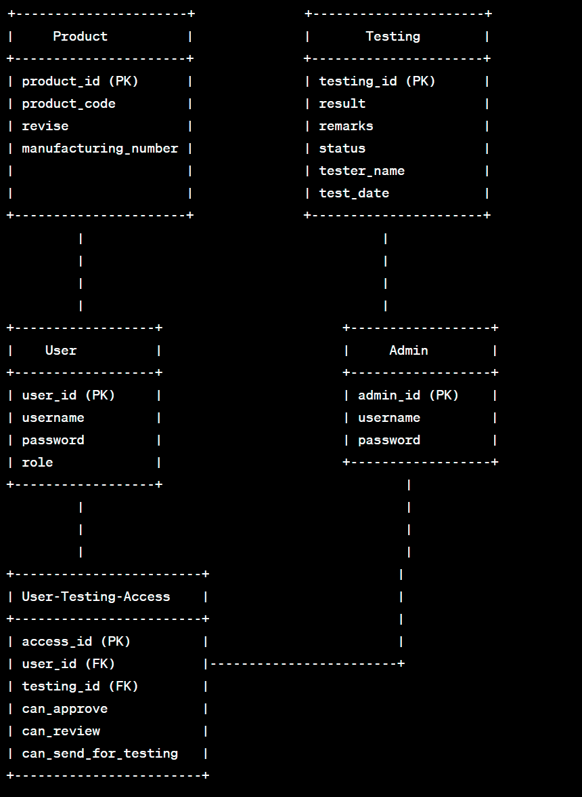

**ER DIAGRMM **

Key:

* (PK): Primary Key
* (FK): Foreign Key

Entities:

1. Product: Represent s the electrical products with details like product code, revise, manufacturing number, etc.
2. Testing: Captures testing details such as testing ID, result, remarks, status, tester name, and test date.
3. User: Represents users with details like user ID, username, password, and role.
4. Admin: Represents administrators with admin ID, username, and password.
5. User-Testing-Access: A junction table to manage the access level of users (Tester and Worker) to specific testing functionalities.

Relationships:

* Product-Testing Relationship: One-to-Many relationship between Product and Testing (One product can undergo multiple testing processes).
* User-Testing-Access Relationship: Many-to-Many relationship indicating the access level of users to specific testing functionalities.

Additional Context:

Roles:

* Tester: Can approve, review, and update the status of the testing.
* Worker: Can upload test details, send products for testing.
* Admin: Has access to all functionalities.

This ER Diagram provides a visual representation of the data structure and relationships within the Lab Automation System, incorporating the roles and functionalities of different users.

Flowchart: User Access Control

**FLOWCHART DIAGRMM **

Flowchart Explanation:

1. The process starts with initiating user access control.
2. Users log in to the system.
3. The system identifies the user role.
4. Admin has full access to all functionalities.
5. Tester has access to approve and review functionalities.
6. Worker has access to upload and send functionalities.
7. The access control process ends.

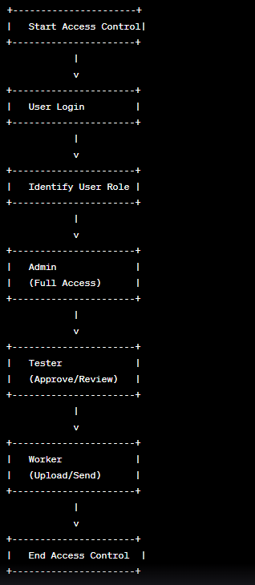

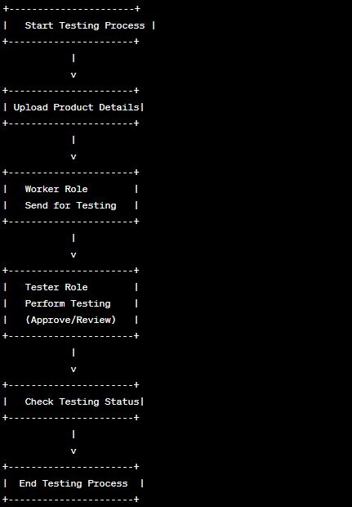

Flowchart: Product Testing Process

Flowchart Explanation:

1. The process starts with initiating the testing process.
2. Product details are uploaded into the system.
3. The Worker role sends the product for testing.
4. The Tester role performs the testing and can either approve or review the results.
5. The testing status is checked.
6. The testing process ends.

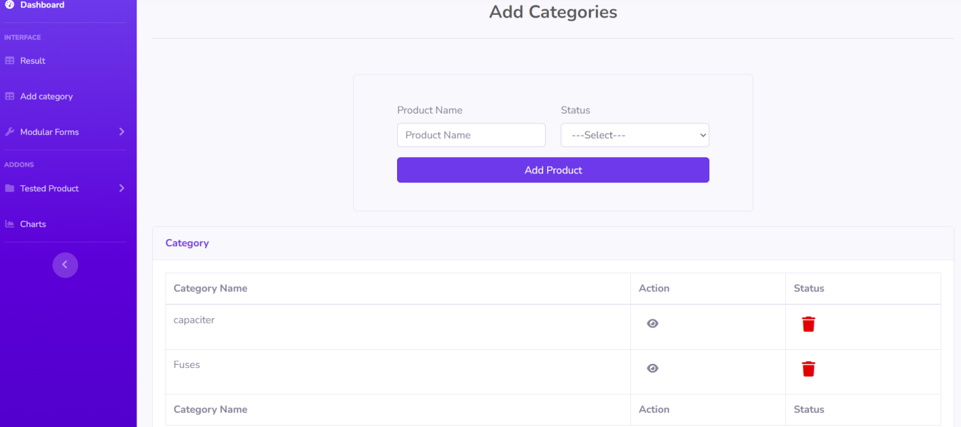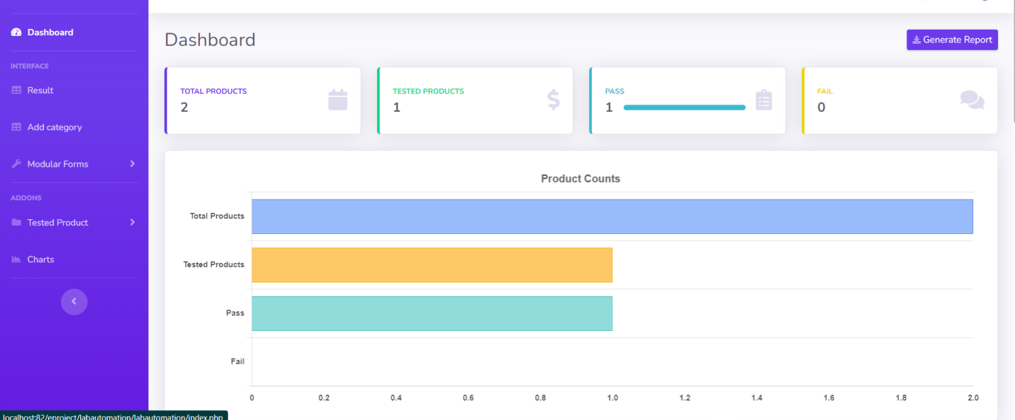

Add Category:

Dashboard:

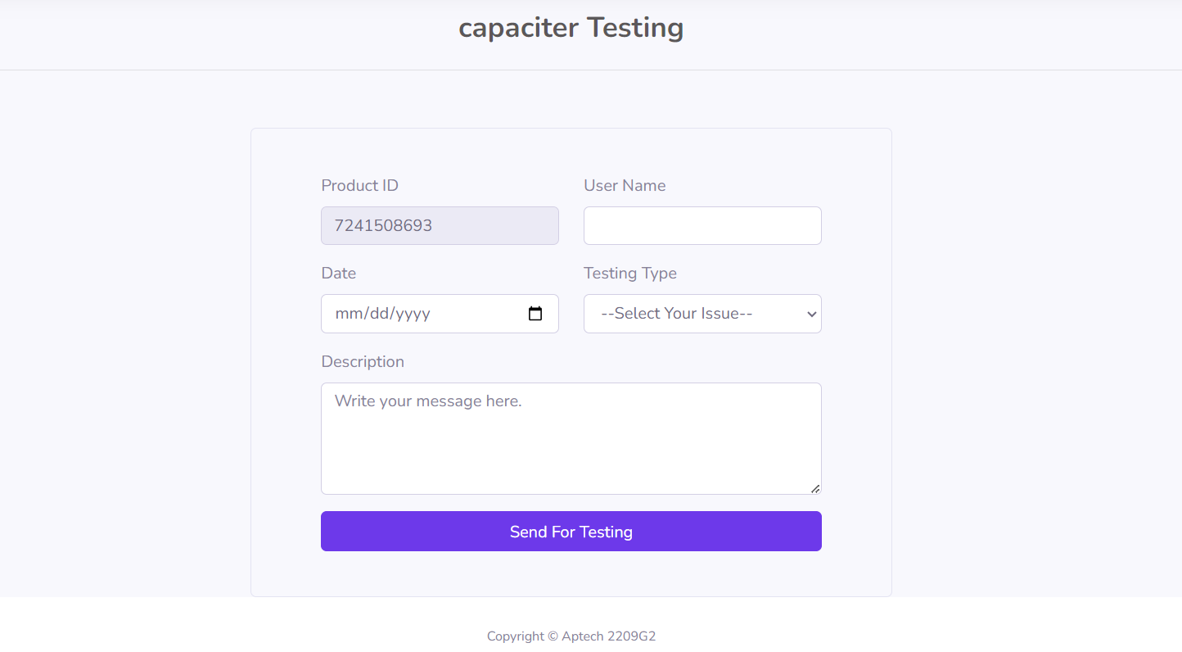

Product Testing Forms:

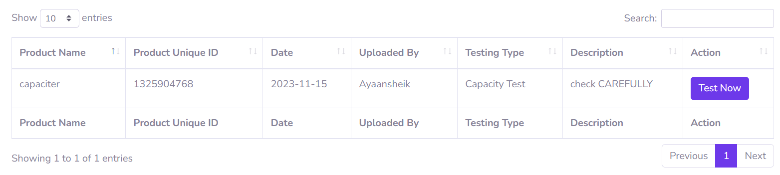

Tested Data:

Testing Product:

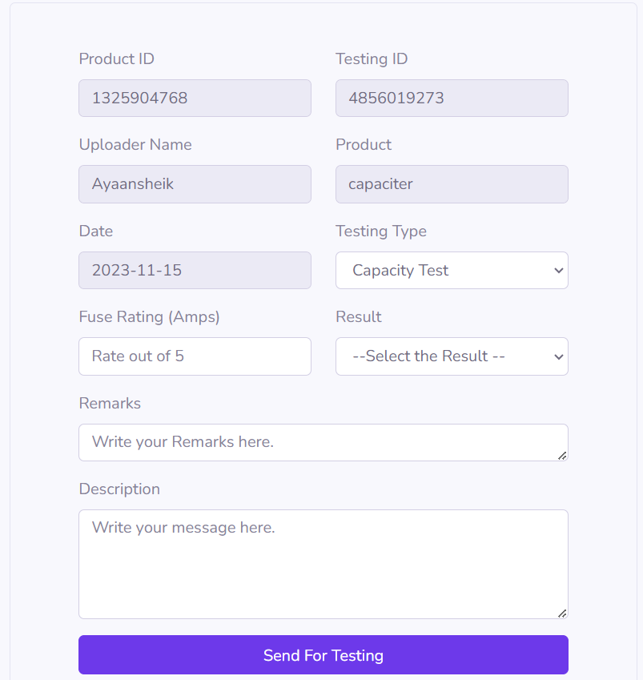

Result:

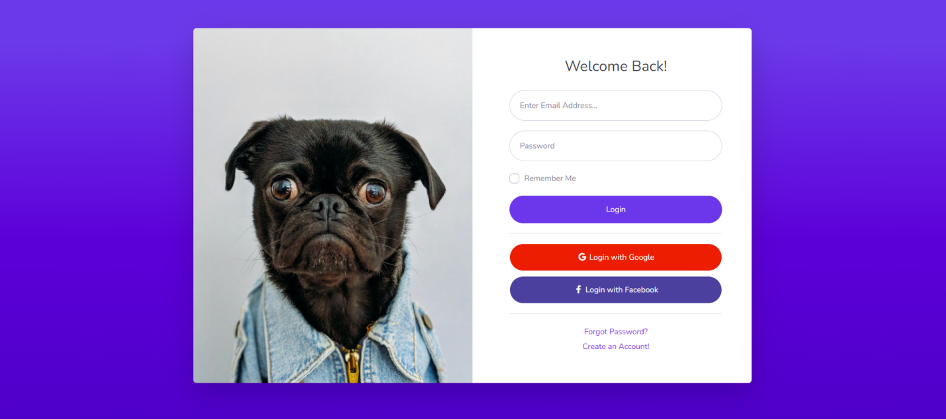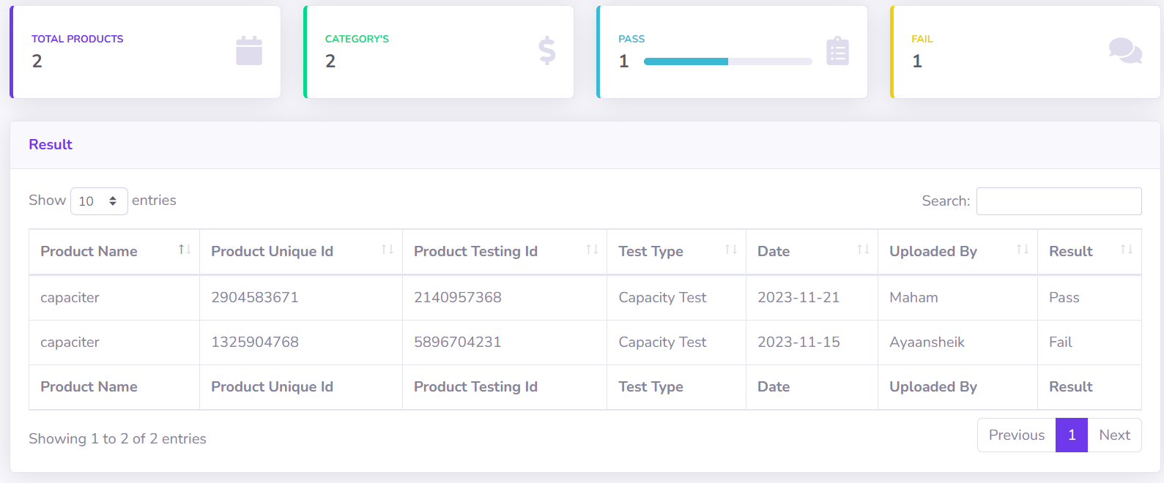

Login:

Register:

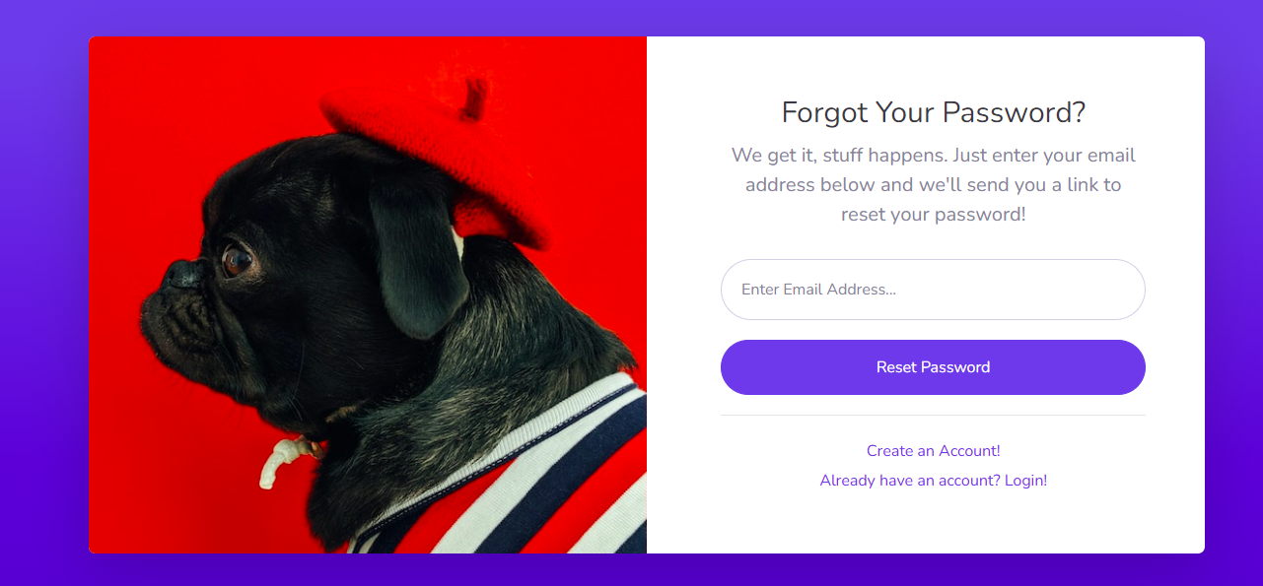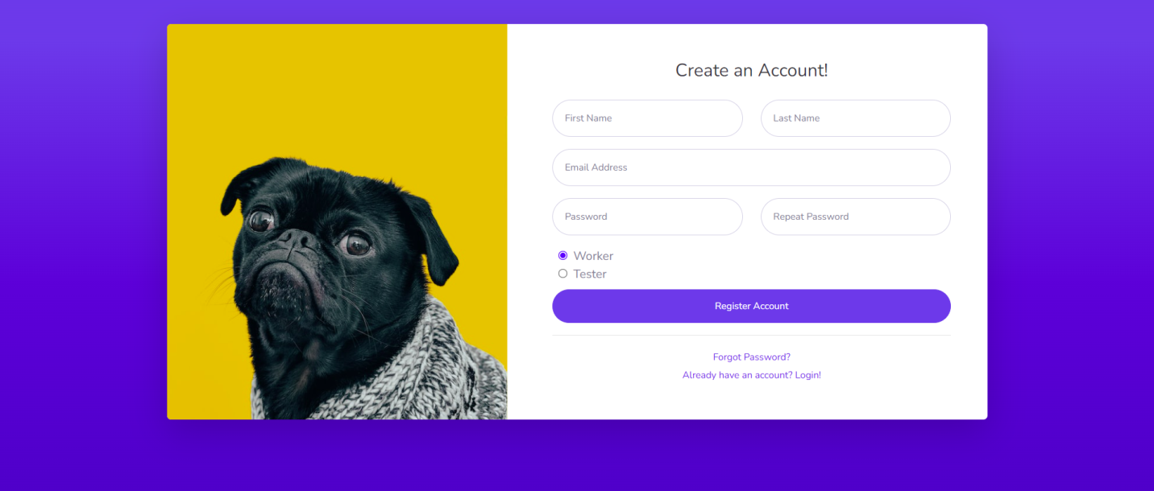

Forget-Password:

Verification-code:

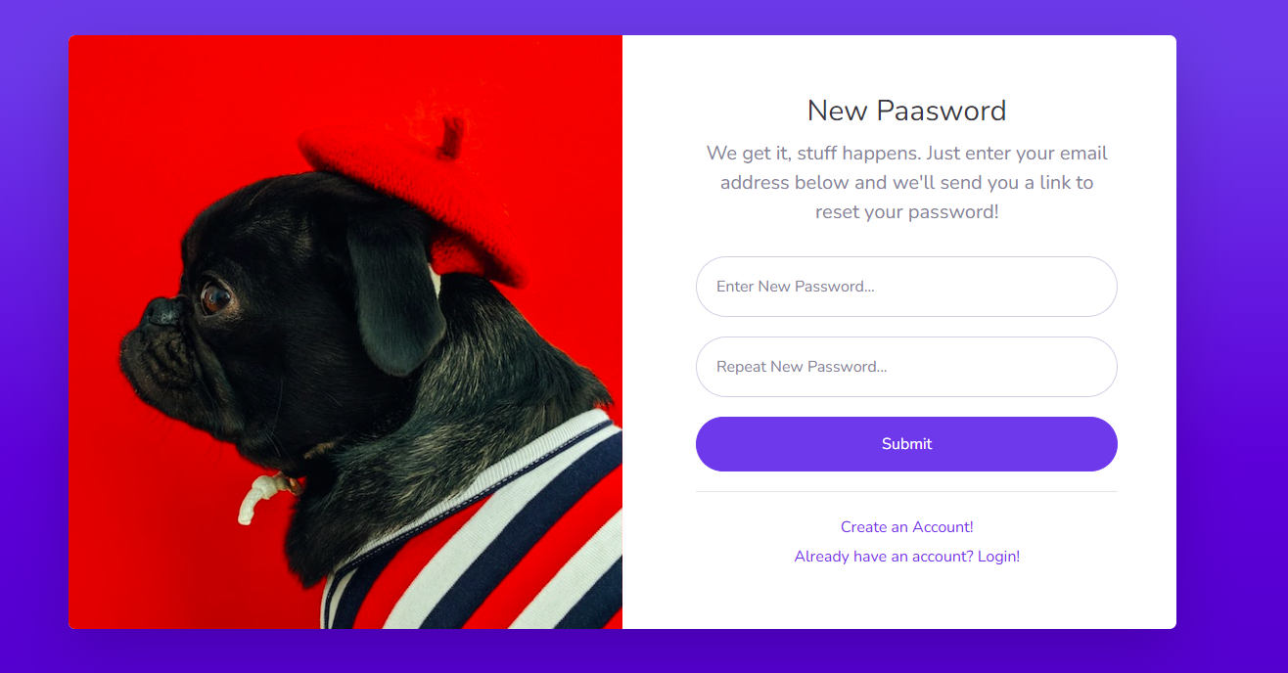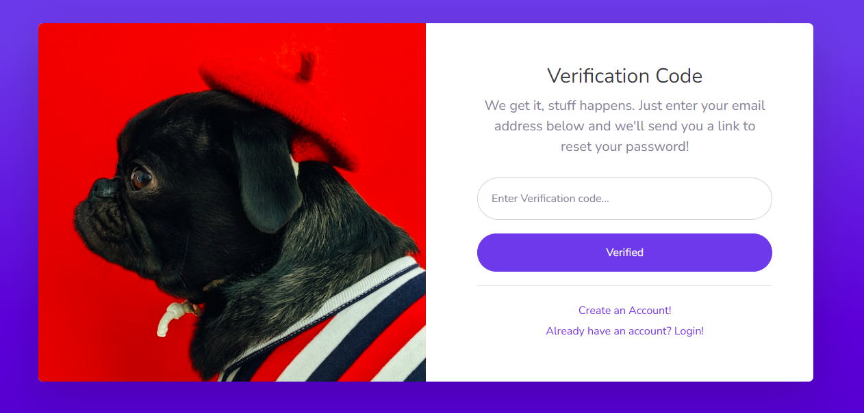

New Password:

Task Sheet:

|  |  |  |  |  |  |  |
| --- | --- | --- | --- | --- | --- | --- |
| S.NO | Task | Project name | Actual start days | Actual days | Team mate name | status |
|  |  |  |  |  |  |  |
| 1 | Frontend | Lab automation | 12-10-23 | 2 days | Faizan | complete |
| 2 | products Page’s | Lab automation | 16-10--23 | 4 days | Faizan | complete |
| 3 | Dashboard | Lab automation | 19-10-23 | 3 days | Faizan | complete |
| 4 | Add Category | Lab automation | 21-10-23 | 3 days | Ayaan | complete |
| 5 | Product uploading | Lab automation | 25-10-23 | 4 day | Faizan , Ayaan | complete |
| 6 | User role query’s | Lab automation | 27-10-23 | 2 days | Ayaan | complete |
| 7 | Testing product | Lab automation | 2-11-23 | 5 days | Faizan , Ayaan | complete |
| 8 | Result page | Lab automation | 6-11-23 | 4 days | Ayaan | complete |
| 9 | AJAX | Lab automation | 8-11-23 | 2 day | Faizan | complete |
| 10 | Documentation | Lab automation | 10-11-23 | 2 days | Ayaan | complete |

**Eproject,**

**Lab automation,**

**Ayaan, Faizan,**

**11-11-2023.**

Dashboard:

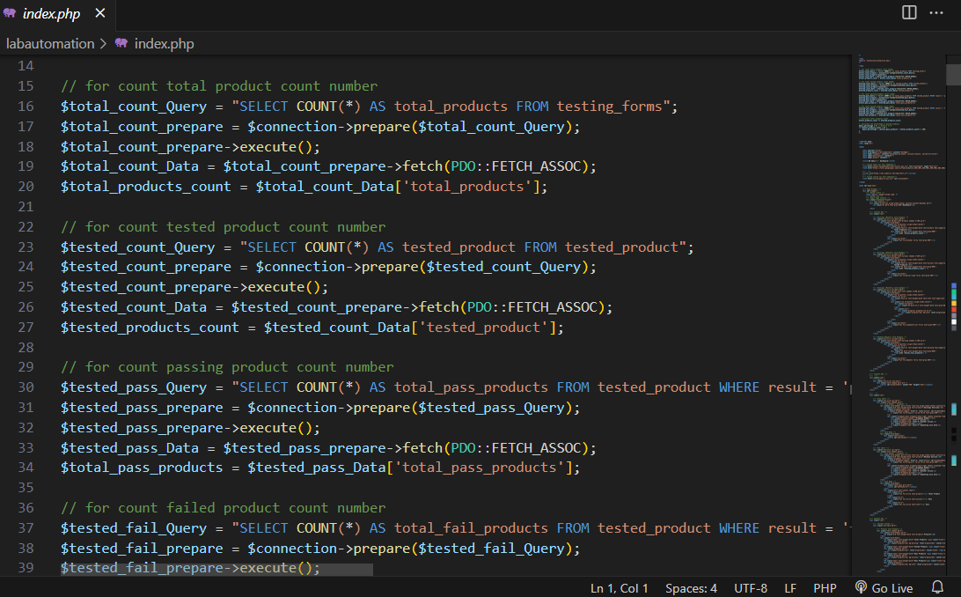

Add Category:

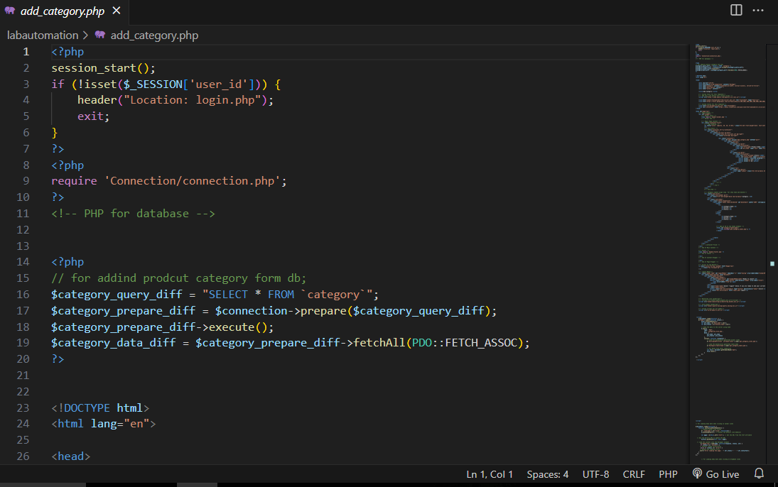

Categories Forms:

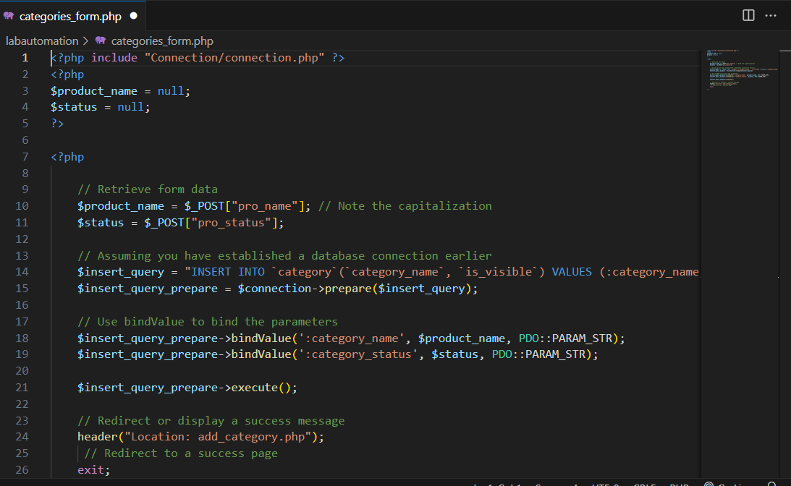

Carts:

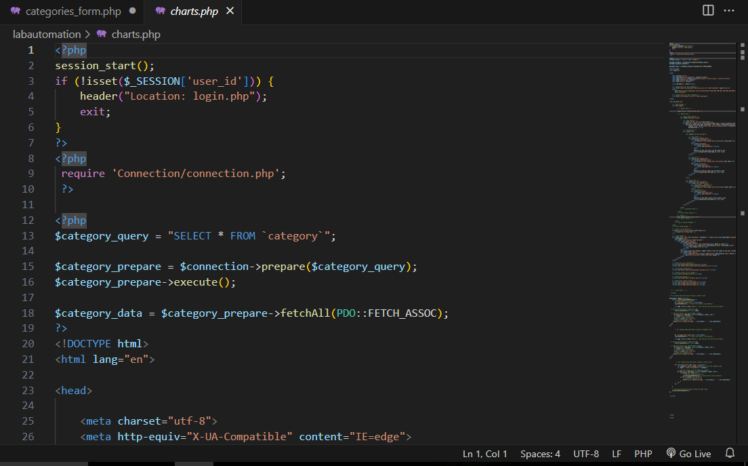

Data all fetch:

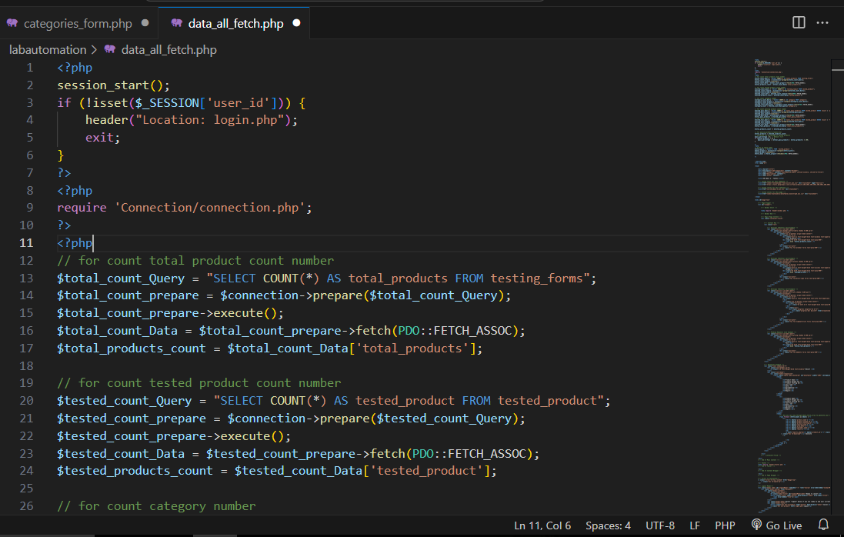

Delete Account: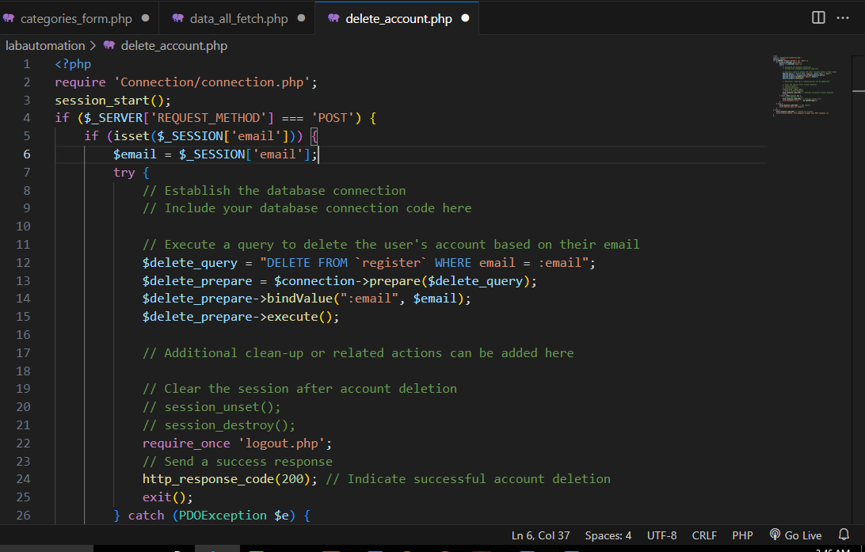

Delete Category :

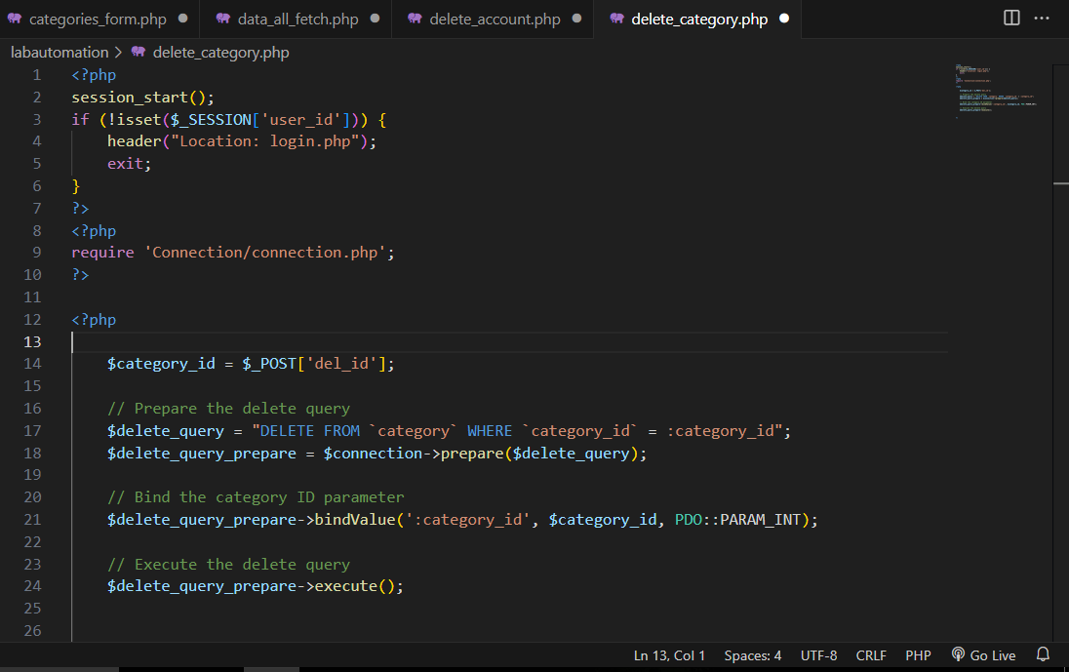Forgot password:

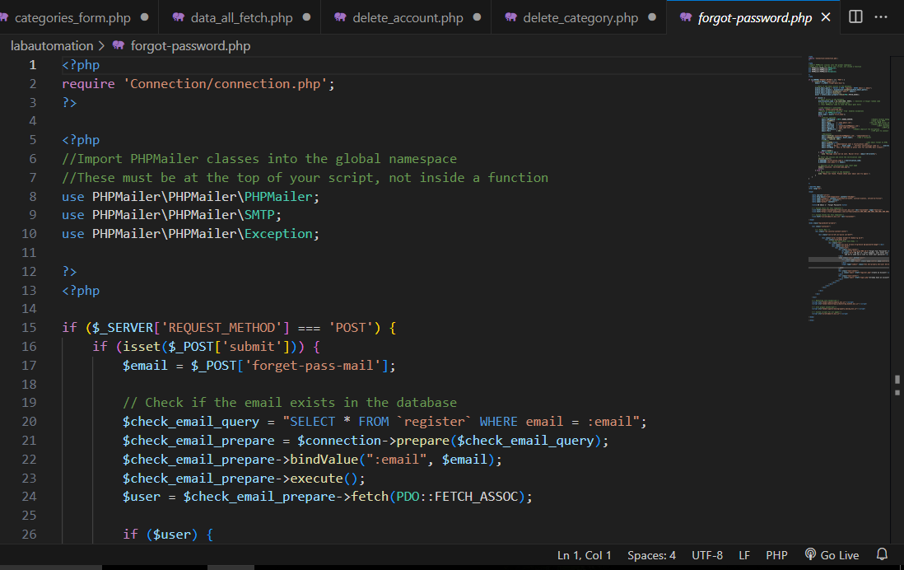

Forms:

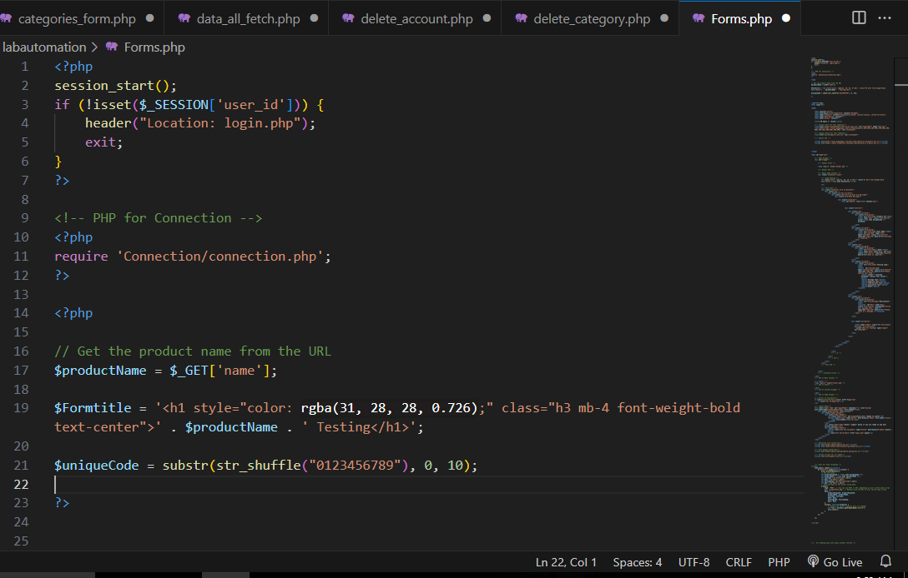

Get Category links : 

Get Category Table:

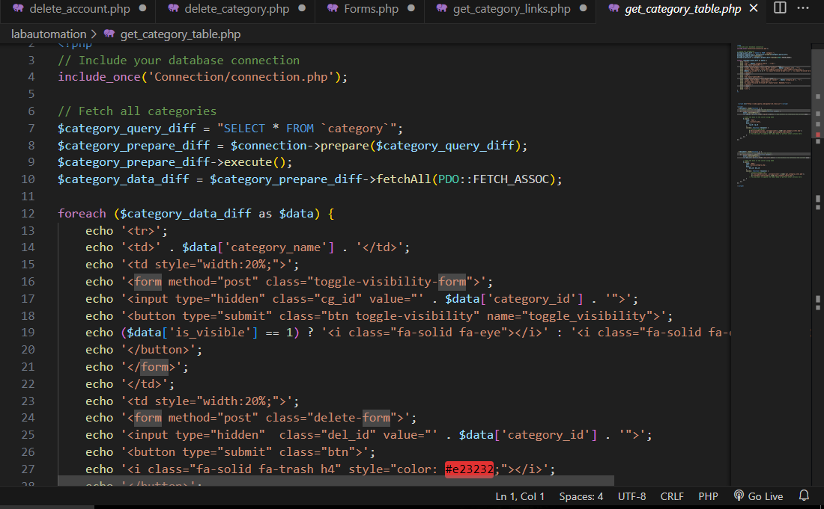

Login: 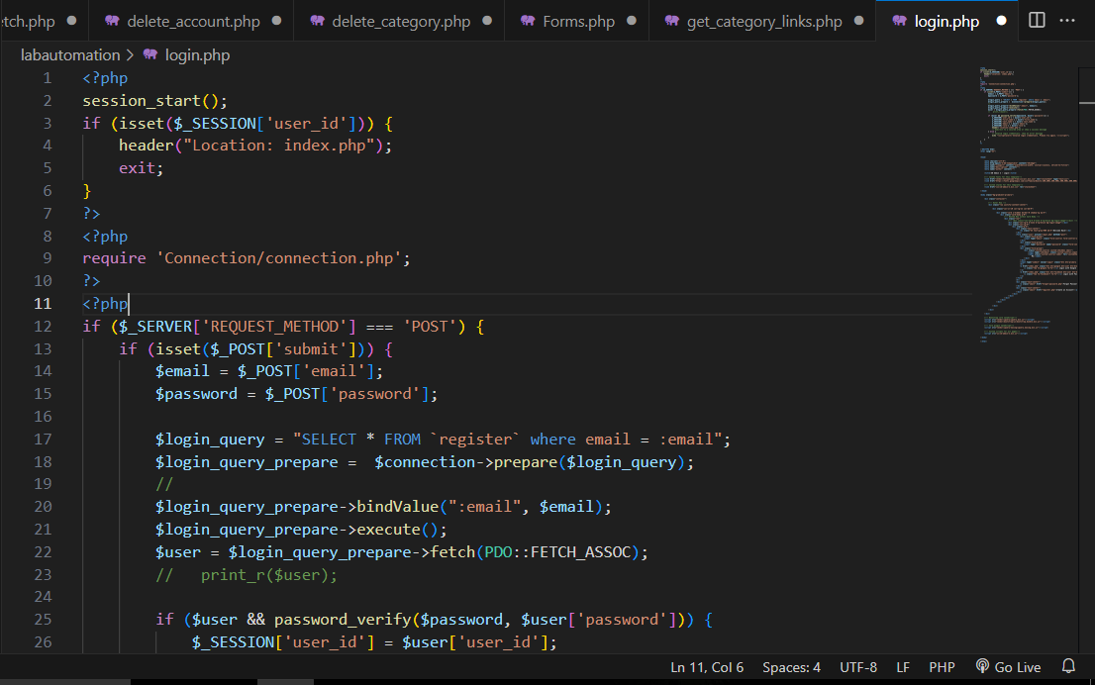

Register:

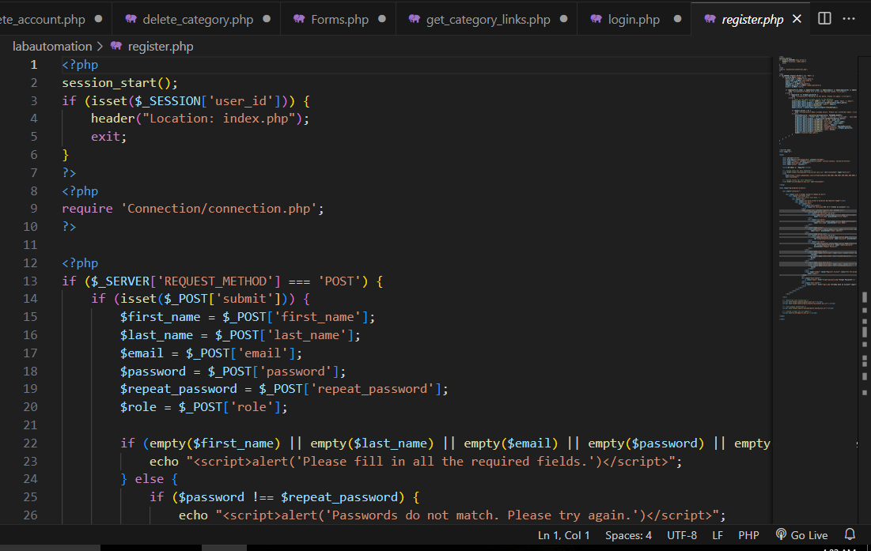

Logout:

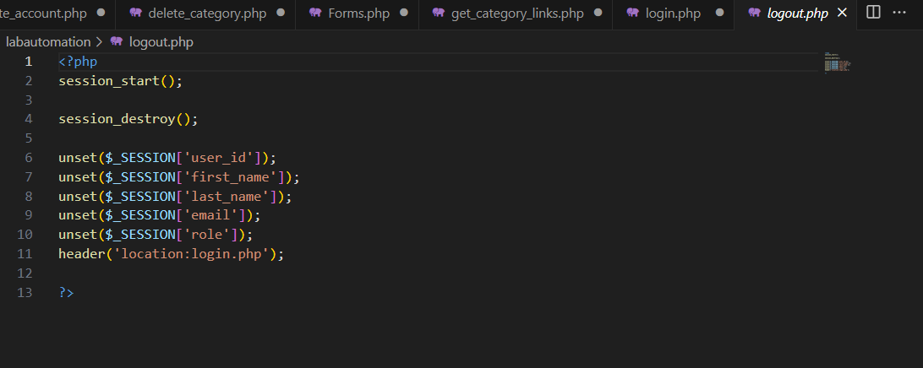

New password field:

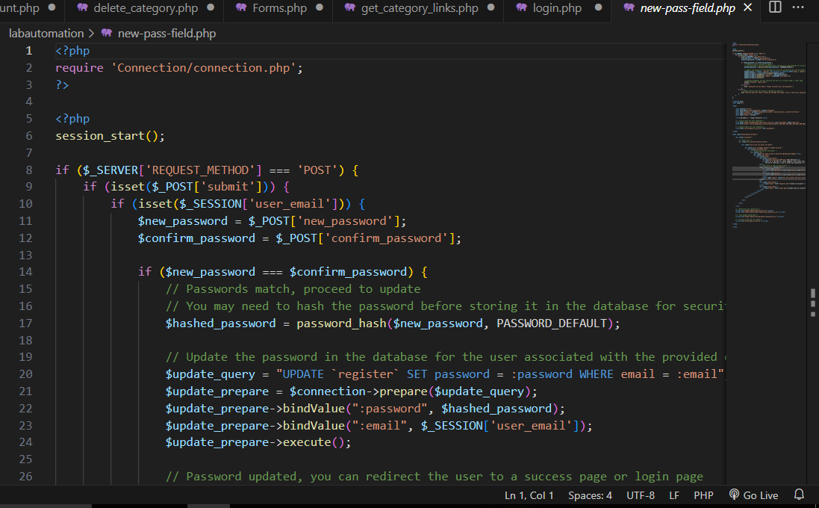

Reports: 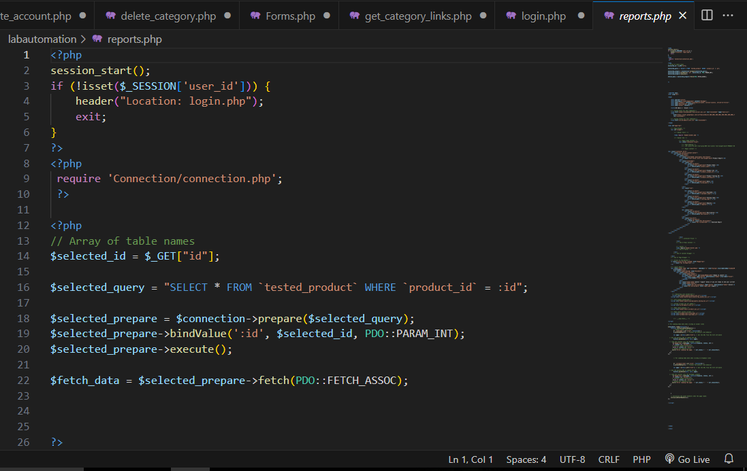

Tester Field form:

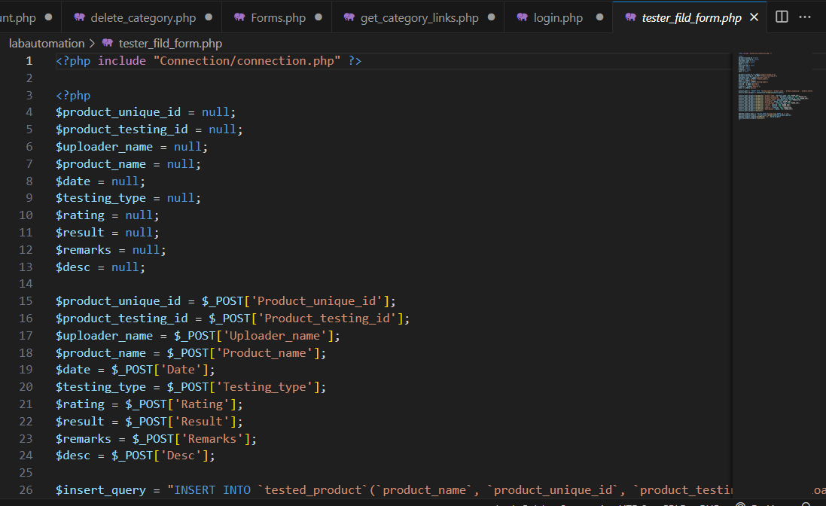

Tester Field:

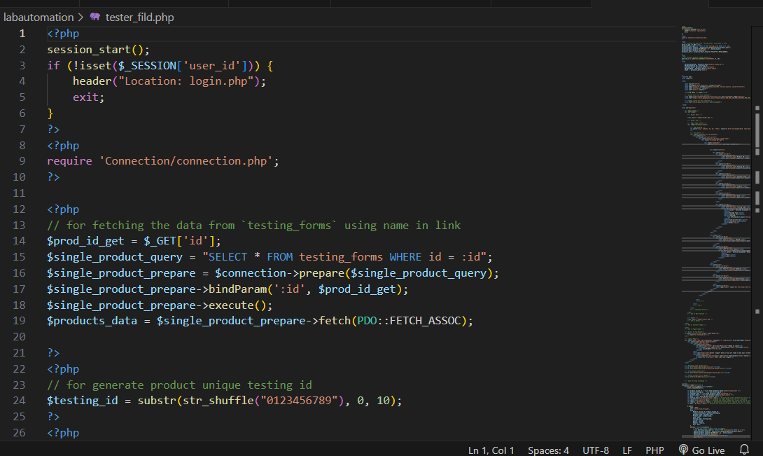

Verified Code:

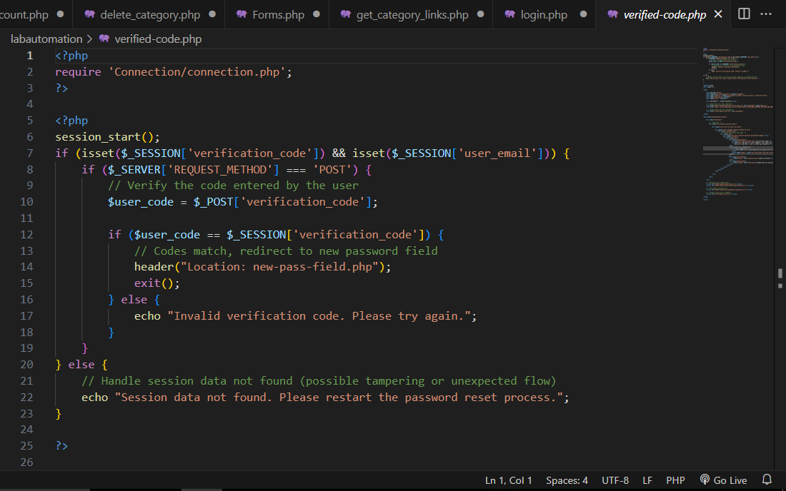

Visible: 

404: 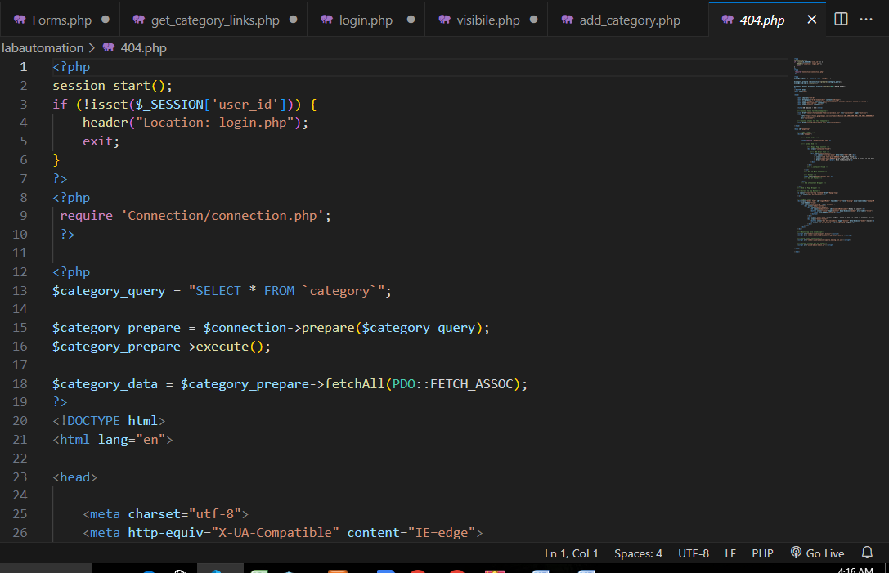Navbar: 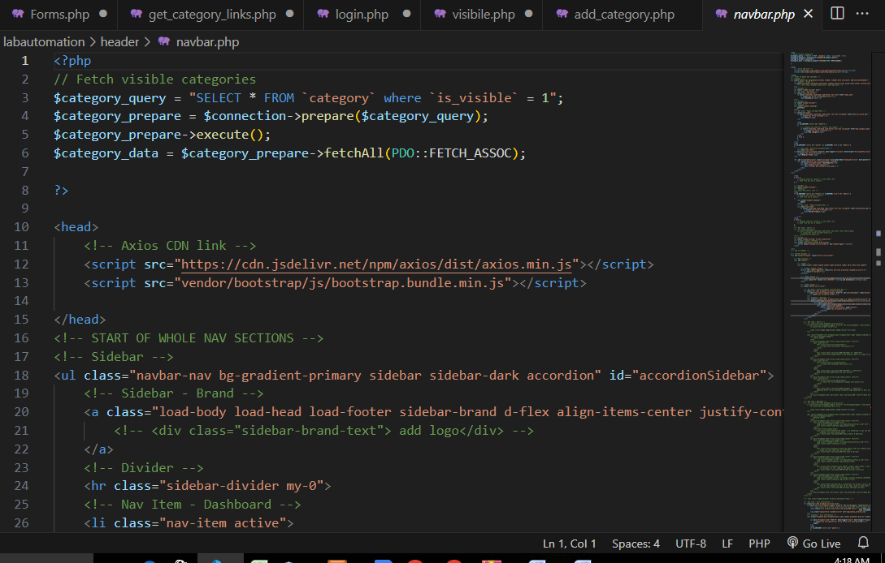

Footer:

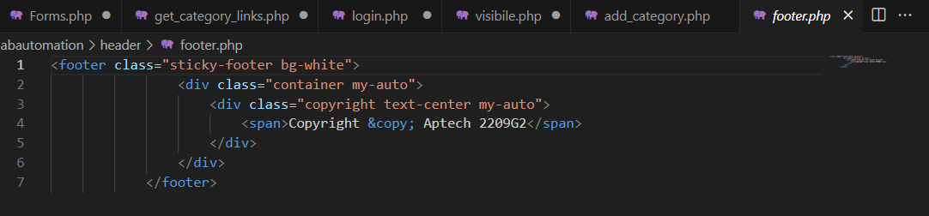

Connection:

